**Assignment-5**

**Join of multiple tables; Nested queries - Sub-queries:**

1. Display empno, emoname, dname and loc from emp and dept table.

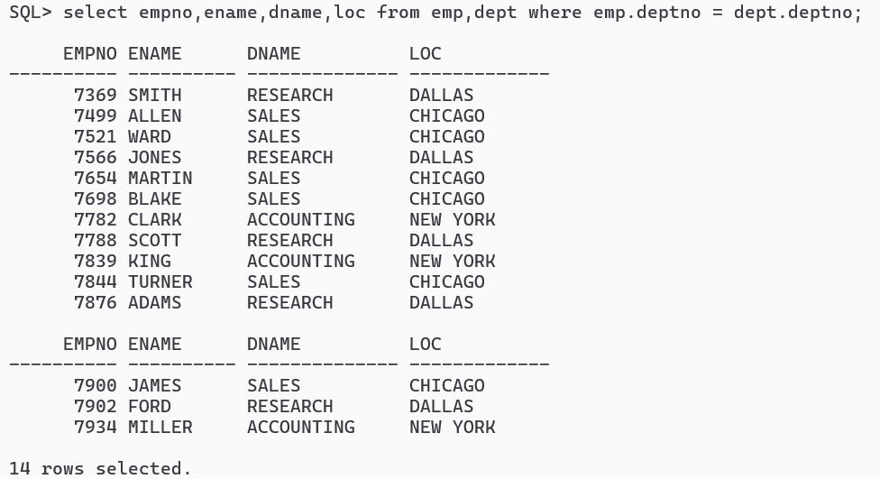

2. Display empno, empname and their deptno, dpetname and loc from emp and dept table.

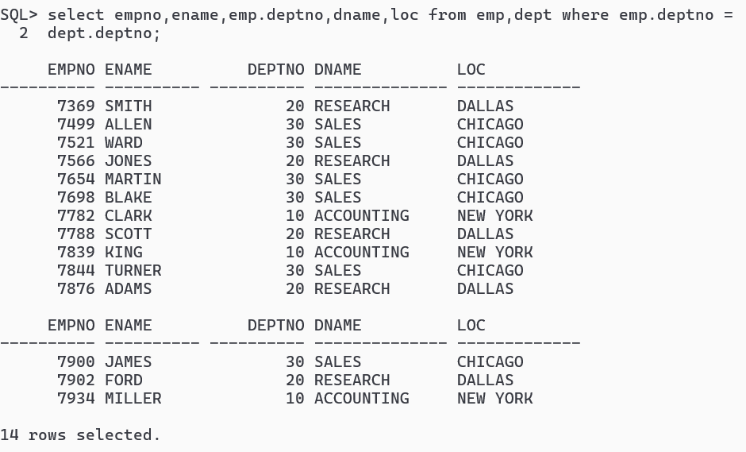

3. Display the list of employees working in each department and with this display the department information even if no employee belongs to that department.

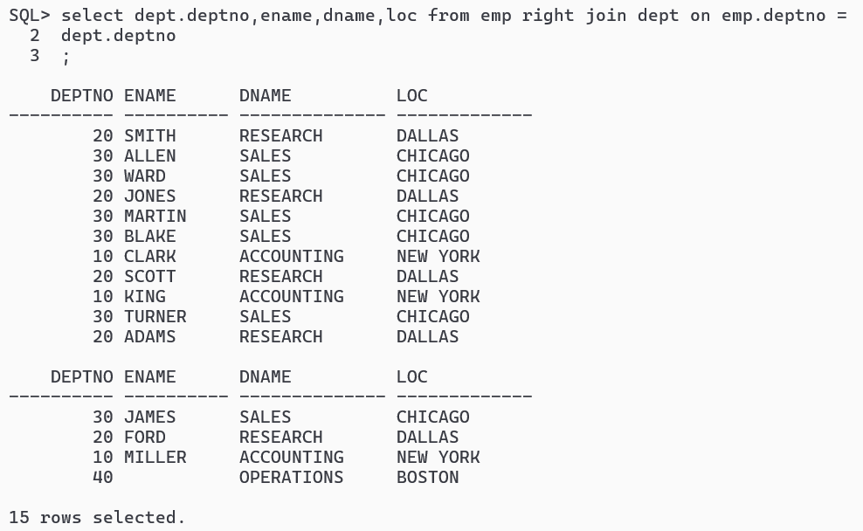

4. List the employee name and their corresponding manager name from emp table.

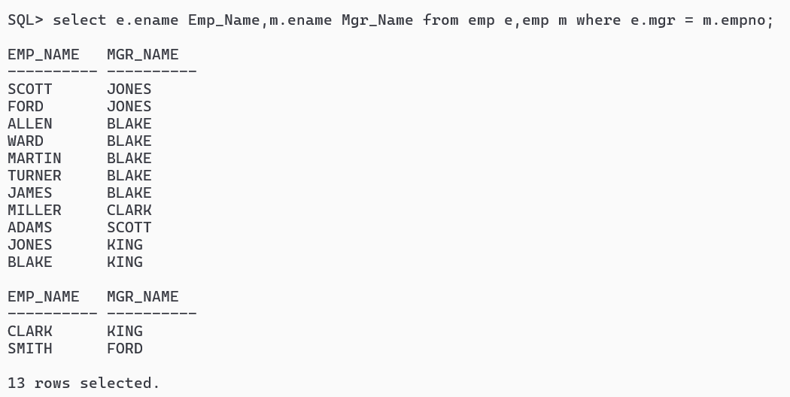

5. List the employee name and their corresponding manager name from emp table along this select that employee who have no manager.

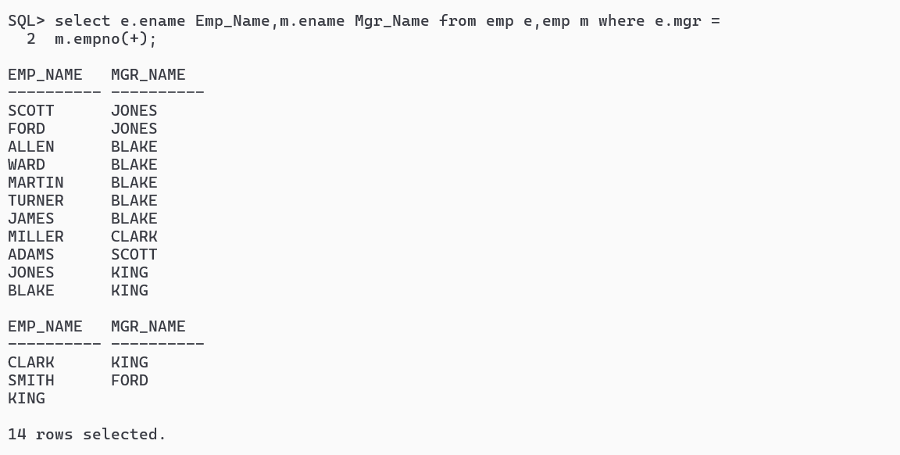

6. List all employees who joined the company before their manager.

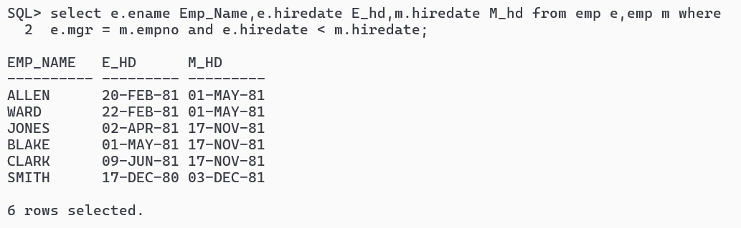

7. Find names, job and salaries of all employees and also his boss.

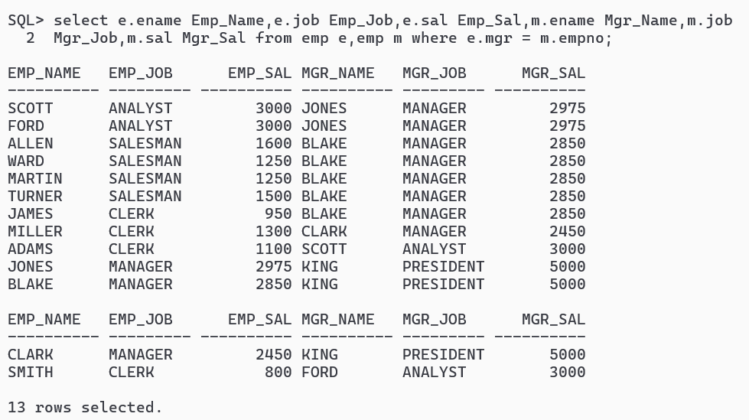

8. Find the names of those employees who earn more than their boss.

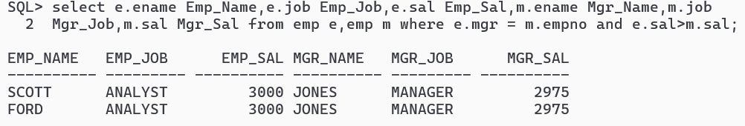

9. How much Miller needs to earn to be in BLAKE’s Grade?

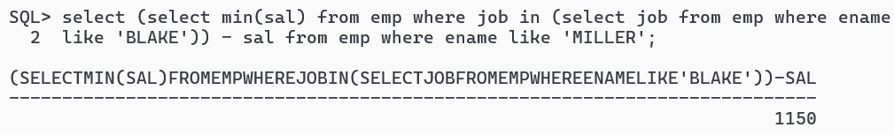

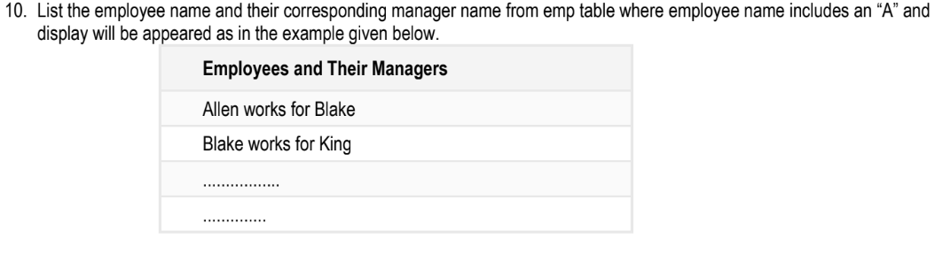

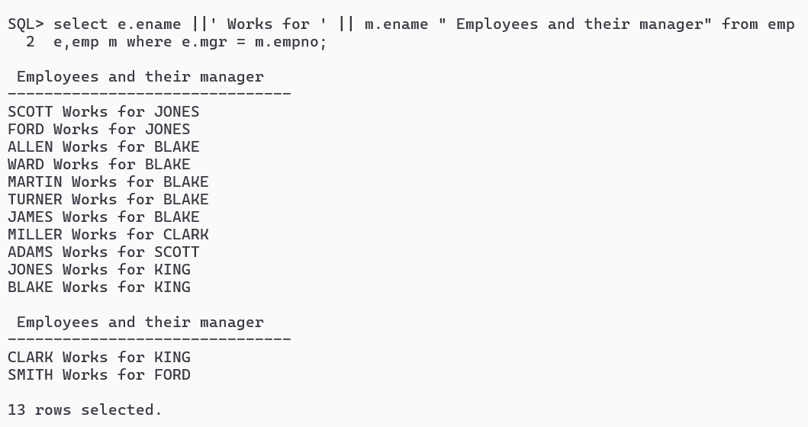

11. Display different designations present in department 20 and 30.

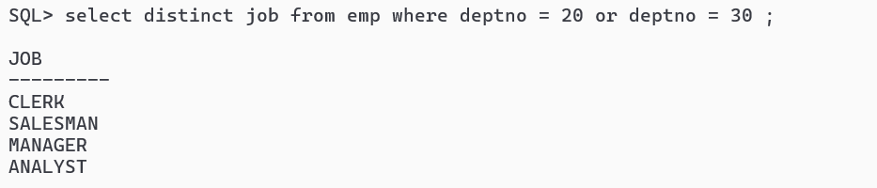

12. List the job common to department 20 and 30.

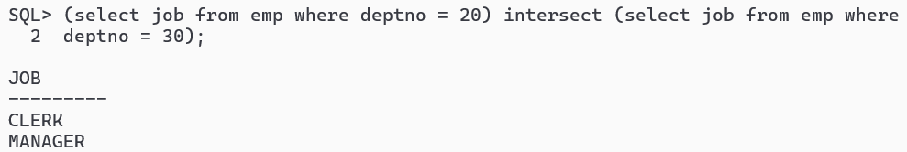

13. List the jobs that are unique to department 20 compare to other departments present in emp table.

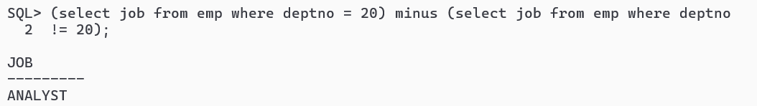

14. List the employees belong to department of MILLER.

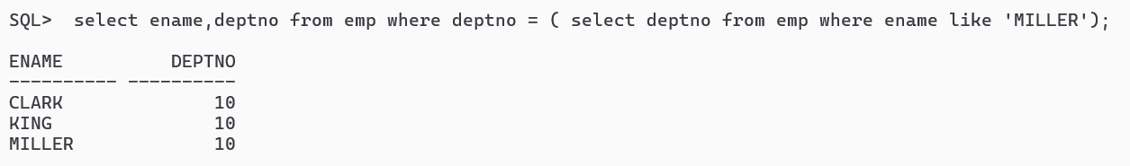

15. Display all employee details whose salary is greater than average salary of employees whose date of joining is before 1st April 81.

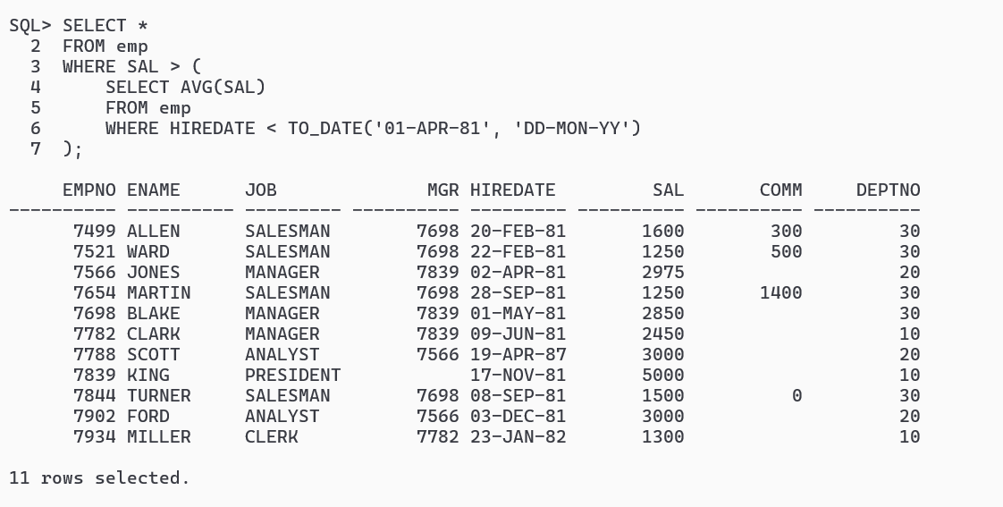

16. List the job with highest average salary.

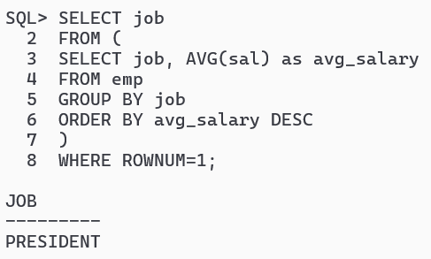

17. Find the details of the employees of the department whose manager no is 7698.

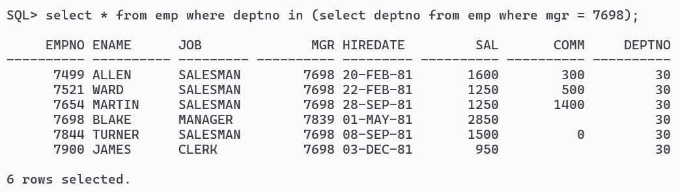

18. List the names of the employees who earn lowest salary in each department.

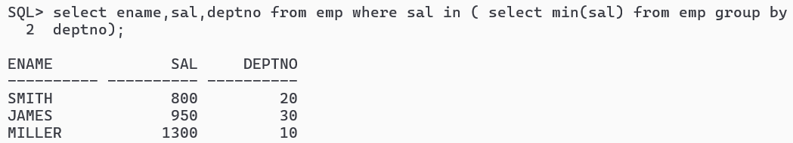

19. List the employee details whose salary greater than the average salary for their department.

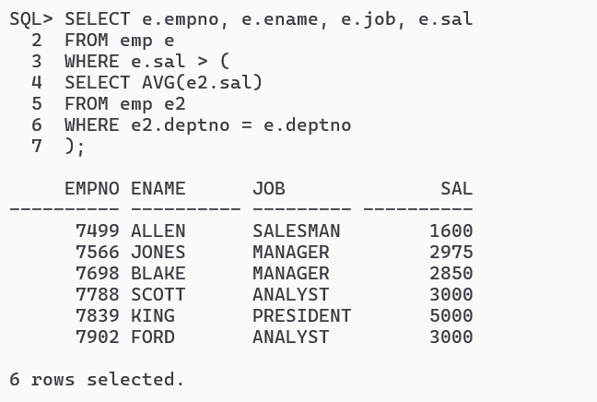

20. List all employees who work in DALLAS and earn more than any employee working in CHICAGO.

